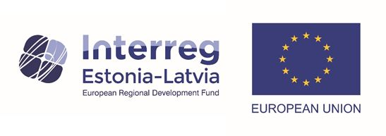

Continuing the ongoing work to improve the efficiency of overall groundwater resources management in the transboundary area, scientists from Latvia and Estonia shared their experience of groundwater assessment in both countries at online seminar on 10 and 11 November this year.

The aim of the seminar was to exchange experiences on the delineation of groundwater bodies and the assessment of their status, as well as the assessment of pressures and experience in citizen science.

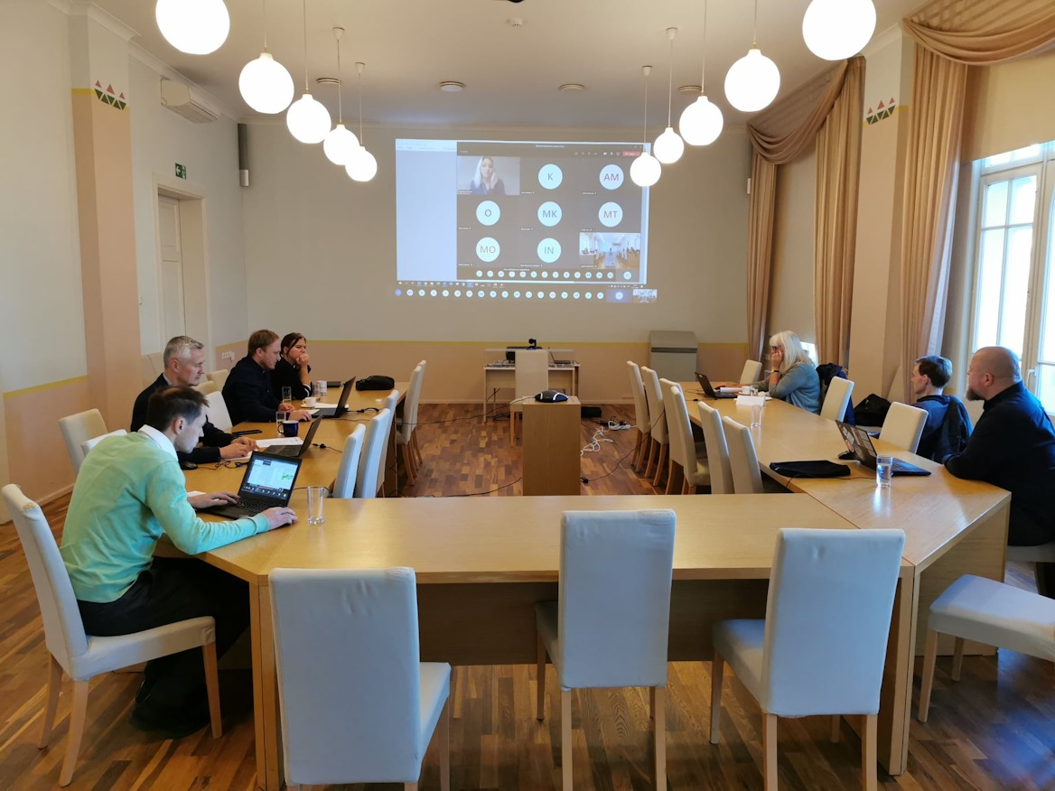

Such examples from the representatives of both countries are a valuable insight for the development of a common and harmonized principles for the assessment of groundwater bodies and the improvement of management efficiency in Latvia and Estonia.

Dean of the Faculty of Biology, University of Latvia Didzis Elferts shared his experience of the programming language R and its capabilities in data analysis. In 2021, training of project partners with R programming language is planned.

Agnese Priede, a representative of the Nature Conservation Agency, outlined several examples of citizen science ([#citizenscience](https://www.facebook.com/hashtag/citizenscience?__eep__=6&__cft__%5b0%5d=AZWtINRHPp0QWzOEktfLGrQUuld1sC_QH88FhGJx5daxqmS6dcMepIyGNaE9P4kqwePbgskSgnQ2odKfneBT6H9Yf4vA4RK2ggcQYAQece0ZsnsiRIg10Imr72aoZy5WNykj-haCkaI1UimHNLkUFpaW&__tn__=*NK-R)) in Latvia and Estonia, explaining how new knowledge about processes in nature is created with the active participation of society. Vidzeme Planning Region in cooperation with Estonia - Latvia Programme project [#WaterAct](https://www.facebook.com/hashtag/wateract?__eep__=6&__cft__%5b0%5d=AZWtINRHPp0QWzOEktfLGrQUuld1sC_QH88FhGJx5daxqmS6dcMepIyGNaE9P4kqwePbgskSgnQ2odKfneBT6H9Yf4vA4RK2ggcQYAQece0ZsnsiRIg10Imr72aoZy5WNykj-haCkaI1UimHNLkUFpaW&__tn__=*NK-R) partners - scientists and researchers, will develop guidelines for spring water observations to invite everyone to go to nature in the spring, to study the springs, while determining their water quality.

Total budget of the projects is EUR 411 764.76. Interreg V-A Estonia-Latvia cross-border cooperation programme contributes EUR 350 000 EUR and partners’ self-contribution is EUR 61 764.76. Project No. Est-Lat155.

Project duration is 24 months (01.06.2020.-31.05.2022.)

Project manager and contact person: Aiga Krauze ([aiga.krauze@lvgmc.lv](mailto:aiga.krauze@lvgmc.lv))

WaterAct is financed from Interreg V-A Estonia-Latvia Cross - border cooperation programme 2014-2020. More information about the programme is available at [www.estlat.eu](https://www.estlat.eu/).

This article reflects the views of the author. The managing authority of the programme is not liable for how this information may be used.