Order for Annual Report in Joint Environmental Information System maintained by LEGMC

Annual Report submission will be possible only when company will sign an Agreement with LEGMC for use of the Joint Environmental Information System (hereinafter - JEIS).

- Entity fills downloaded template of the Agreement and annex. The Agreement and annex are available at LEGMC website.
- Entity verifies that provided information in the Agreement and form of the annex has been completed.
- Sign the Agreement.
- Entity must send signed Agreement and annex to LEGMC (in two copies).
- Entity will be informed by e-mail about the possibility of the starting data input in the online database.

The Agreement and annex must be sent in two copies for each legal entity.

LEGMC creates user/-s in the JEIS based on the data of the annex of the Agreement for the system use.

NB! Please indicate the existing and correct e-mail address, it will be used as a username in JEIS.

After receiving information for user creation in JEIS and registration on the web site https://videscentrs.lvgmc.lv/ (for this one you will receive automatic system response e-mail from no-replay@lvgmc.lv) a new user needs a make the authorization on LEGMC website:

- Open https://videscentrs.lvgmc.lv/.
- Please follow the steps 1 to 5 listed below to open the JEIS:

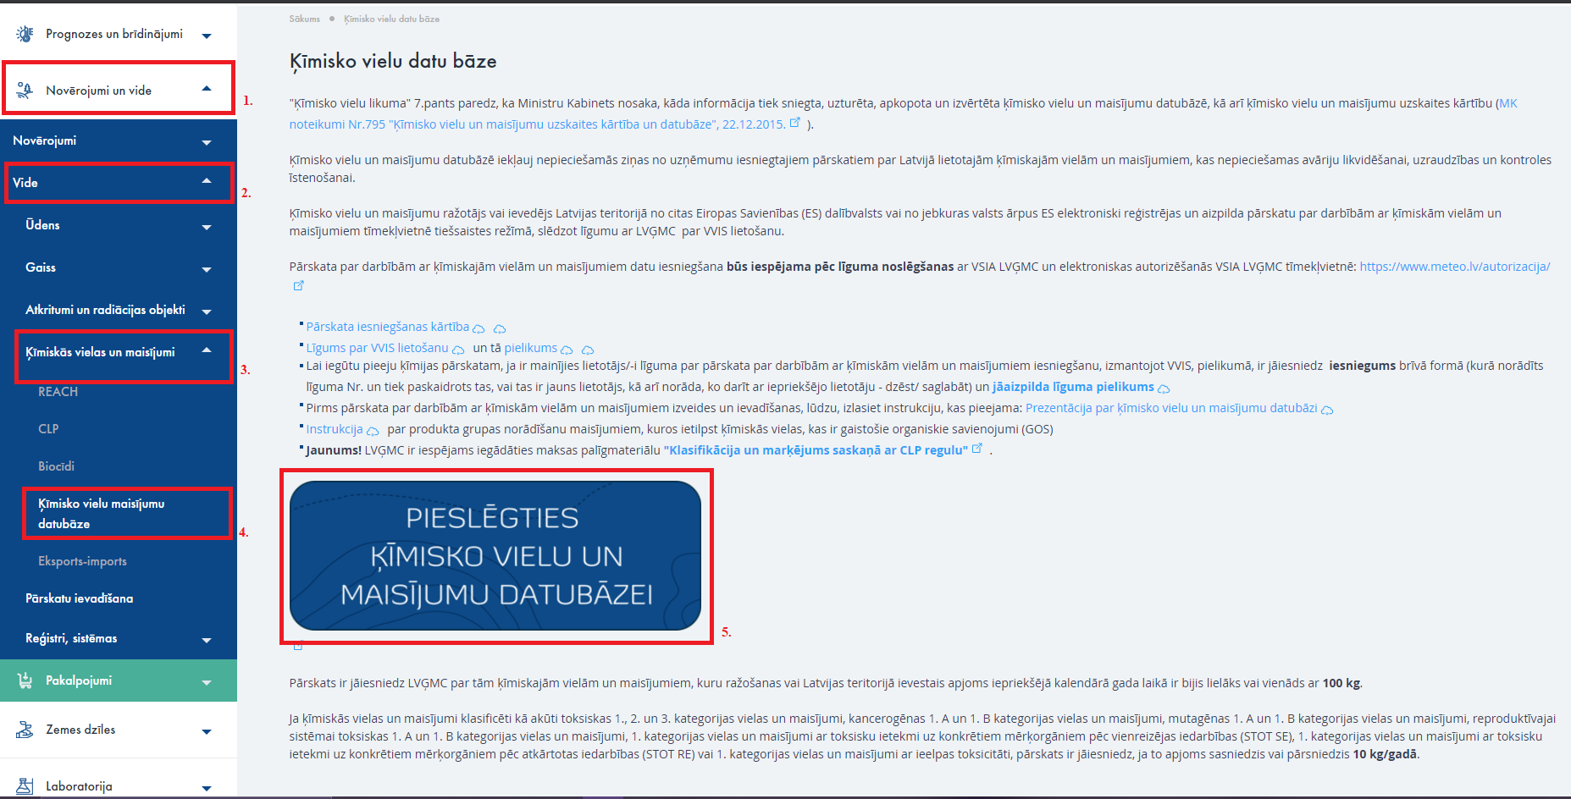
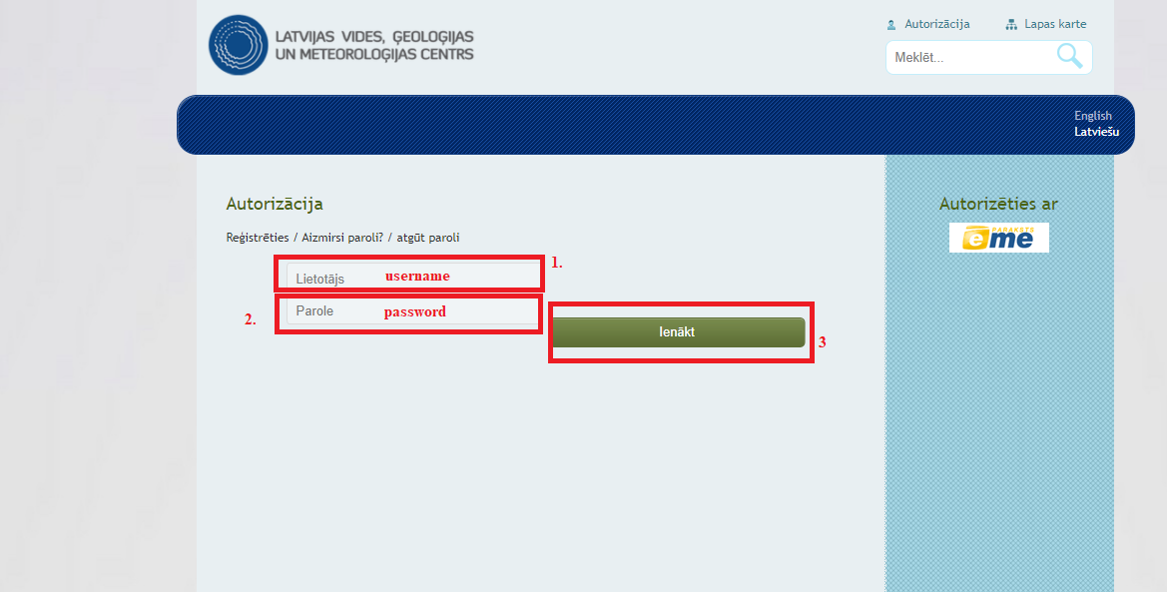
- Please log in:

- System is open. You can begin work on Annual Report in JEIS:
